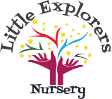
Healthy Packed Lunch Policy
Why do we need a healthy lunch box policy?
The government has placed a duty on schools and nurseries to ensure that every child is healthy. Eating healthily is important because it will help children to:
- Be fitter and healthier now and later in life.
- Learn at faster pace and behave better.

Statement of intent:
To make sure that children who bring a lunch from home to eat in nursery have food which is just as healthy and nutritious as food served in nursery.

The Policy
The Nursery will provide facilities for children bringing in packed lunches and ensure that free, fresh drinking water and milk is available.
- The nursery will work with the children to provide attractive and appropriate eating arrangements.
- The nursery will work with parents to ensure that packed lunches are as close as possible to the guidance below.
- The nursery will allow children eating packed lunch or nursery meals to sit together.
Parents will need to provide children with a suitable container which must be clearly labelled with your child’s name.
- Children must only eat their own food and no other children’s especially in case of allergies, staff are always present during lunch time to ensure this.
Guidance:
- Suggestions for food to include in a healthy packed lunch
- At least one portion of fruit or vegetables every day.
- Meat, fish or other source of non-dairy protein (e.g. lentils, beans, soya or hummus,) every day (usually as part of a sandwich, roll or salad).
- Oily fish, such as pilchards, salmon or tuna occasionally.
- A starchy food such as bread, Pitta or wraps. Dairy food such as milk, cheese, yoghurt, fromage frais or custard. (This does not include Dairylea lunchables or similar products).
- Cereal bars rather than cakes and biscuits (cereal bars should not contain nuts)
- Pretzels, seeds, fruit, crackers and cheese, and vegetable or bread sticks with a dip.
Suggestions for food to include less often in a healthy packed lunch (once a week)
- Snacks such as crisps.
- Chocolate coated biscuits or wafers.
- Cakes
- Meat and pastry products such as sausage rolls or pies

Suggestions for food to not include in a healthy packed lunch.
Confectionery such as chocolate bars. Sweets are not allowed at lunch or any other time.
Nuts (including nut products) or Egg (although they can be very healthy) because of the danger to other children with allergies.
Fizzy drinks, Juice or Smoothies as these are mostly very unhealthy.
We will provide drinks for the children – you do not need to provide.
Special diets
The Nursery also recognizes that some pupils may have verified medical conditions requiring special diets that do not allow for the standards to be met exactly. In this case parents are urged to be responsible in ensuring that packed lunches are as healthy as possible. If any of the foods suggested on the not to include list need to be a part of your child’s daily diet, please inform a member of the management team.
Storage
Packed lunches will be kept out of direct sunlight and must have a freezer bock inside, packed lunches not in a freezer block will be kept in the fridge.
As a nursery we support sustainability and ask that you use re-usable packaging in lunchboxes reducing the use of cling film and one-use plastic packaging.

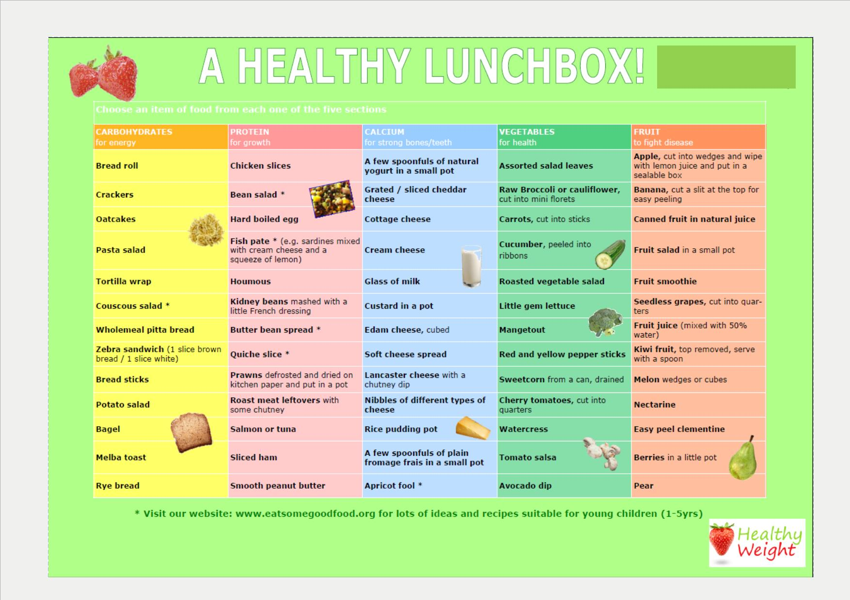

Policy created by: C Smith
Dated created: 01/02/2021
Date last reviewed: Feb 22
Reviewed by: C Smith
Next review date: Feb 23

