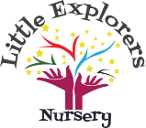
Healthy Packed Lunch Policy
Why do we need a healthy lunch box policy?
The government has placed a duty on schools and nurseries to ensure that every child is healthy. Eating healthily is important because it will help children to:
- Be fitter and healthier now and later in life.
- Learn at faster pace and behave better.

Statement of intent:
To make sure that children who bring a lunch from home to eat in nursery have food which is just as healthy and nutritious as food served in nursery.

The Policy
The Nursery will provide facilities for children bringing in packed lunches and ensure that free, fresh drinking water and milk is available.
- The nursery will work with the children to provide attractive and appropriate eating arrangements.
- The nursery will work with parents to ensure that packed lunches are as close as possible to the guidance below.
- The nursery ensures all age groups of children in the nursery eating sit together.
Parents will need to provide children with a suitable container which must be clearly labelled with your child’s name.
- Children must only eat their own food and no other children’s especially in case of allergies, staff are always present during lunch time to ensure this.

Guidance:
- Suggestions for food to include in a healthy packed lunch
- At least one portion of fruit or vegetables every day.
- Meat, fish or other source of non-dairy protein (e.g. lentils, beans, soya or hummus,) every day (usually as part of a sandwich, roll or salad).
- Oily fish, such as pilchards, salmon or tuna occasionally.
- A starchy food such as bread, Pitta or wraps. Dairy food such as milk, cheese, yoghurt, fromage frais or custard. (This does not include Dairylea lunchables or similar products).
- Cereal bars rather than cakes and biscuits (cereal bars should not contain nuts or be covered in chocolate)
- Pretzels, seeds, fruit, crackers and cheese, and vegetable or bread sticks with a dip.

Suggestions for food to include less often in a healthy packed lunch (once a week)
- Snacks such as crisps.
- Biscuits or wafers.
- Cakes (non chocolate)
- Meat and pastry products such as sausage rolls or pies

Food to not include in a healthy packed lunch.
Confectionery such as chocolate bars. Sweets are not allowed at lunch or any other time; no sweets will be consumed at nursery.
Nut or nut products or Egg (although they can be very healthy) because of the danger to other children with allergies.
No Fizzy drinks, Smoothies or Juice (Milk and water are provided) – provide a named empty drinks bottle, checks will be carried out and staff will tip any juice etc away and replace with water.
No Chocolate or chocolate covered items – we do allow chocolate chips.
We ask that parents of children over 2 years of age provide an alternative to sweetened yoghurts such as Fromage Frais / Frubes to plain un sweetened alternatives.
Celebrations – We now ask that children do not bring in cakes to celebrate birthdays, if you wish to provide anything then we suggest a fruit platter to share with friends or non-edible options such as bubbles or stickers to give out to friends.
We ask that you do not provide dried pasta / noodle pots as part of packed lunches.
Special diets
The Nursery also recognizes that some pupils may have verified medical conditions requiring special diets that do not allow for the standards to be met exactly. In this case parents are urged to be responsible in ensuring that packed lunches are as healthy as possible. If any of the foods suggested on the not to include list need to be a part of your child’s daily diet, please inform a member of the management team. A supporting letter from a medical professional will be required.
Storage
Packed lunches will be kept out of direct sunlight and must have a freezer bock inside, packed lunches that do not have a freezer block in will be kept in the fridge.
As a nursery we support sustainability and ask that you use re-usable packaging in lunchboxes reducing the use of cling film and one-use plastic packaging.

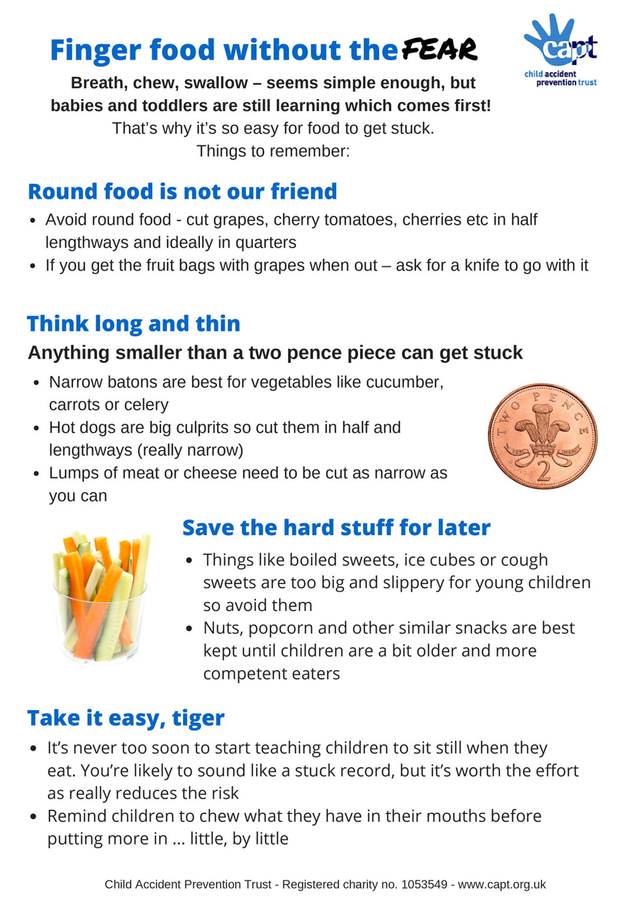
Packed Lunch Ideas
Carbohydrates –  For energy | Protein –  For growth | Calcium –  For strong bones / teeth | Vegetables –  For health | Fruit –  To fight disease
Bread rolls | Chicken slices | Plain Natural yoghurt | Salad leaves | Apples
Crackers | Bean Salad | Sliced cheddar | Raw broccoli or cauliflower florets | Bananas
Oatcakes | Fish pate | Cottage cheese | Carrots – cut into sticks | Fruit salad - homemade
Pasta salad | Houmous | Custard pots | Cucumber – cut into sticks | Seedless grapes – cut in quarters
Tortilla wraps | Ham slices | Edam cheese cubed | Roasted vegetable salad | Blueberries – cut into quarters
Couscous salad | Meat pate | Soft cheese spread | Little gem lettuce | Melon – wedges or cubes
Wholemeal pitta bread | Salmon or Tuna | Rice pudding pots | Sweetcorn | nectarines
Zebra bread – 1 slice brown / 1 slice white | Lentils | Plain Greek Yoghurt | Salsa dip | Easy peel clementines
Bread sticks | Bean salad | Breakfast bars – no nuts or chocolate | Avocado dip | Berries – in a little pot cut in to quarters
Potato salad | Turkey slices | Homemade cheese pizza | Celery sticks | Pears
Bagels | Fish sticks | Macaroni cheese | Peas in a pod | Peaches
Melba toast | Mozzarella string cheese | Oranges | Gherkins | Baby tomatoes – cut in quarters
Rye bread | Baked beans | Broccoli | Beetroot | Plums

Policy created by: C Smith
Dated created: 01/02/2021
Date last reviewed: January 2026
Reviewed by: C Morgan
Next review date: September 2027

